**Source:** <https://forum.xda-developers.com/showpost.php?s=e343d41b240f7b30f66f9d78a4d74336&p=65775601&postcount=2>

**FAQ:**  
**Q: I'm getting an error brut.androlib.AndrolibException: brut.common.BrutException: could not exec (exit code = -1073741515):**  
A: You are using apktool 2.4.0, it have aapt related issues <https://github.com/iBotPeaches/Apktool/issues/2141>. There are some ways to fix it:  
- Uninstall Java 32-bit and install Java 64-bit. Versions doesn't matter i think.  
- Download apktool 2.3.4 jar or older, place them in [path of APK easy tool]\Apktool\ and switch apktool version in Options.

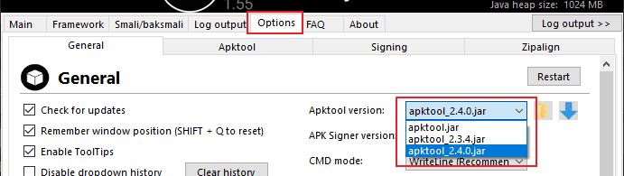

**Q: I'm getting resource error: brut.androlib.AndrolibException: brut.common.BrutException: could not exec:**  
A: Either clear framework (In Framework tab) or download apktool 2.3.4 jar or older, place them in [path of APK easy tool]\Apktool\ and switch apktool version in Options.



You can download older versions of apktool here: <https://bitbucket.org/iBotPeaches/apktool/downloads/>  
  
**Q: I can't decompile or compile**  
A: It's not unusual that it won't decompile or compile. Check the log output what it says. Search on Google or search issue on <https://github.com/iBotPeaches/Apktool/issues/>  
The common issues are invalid syntaxes, corrupted APK, resource error, etc.  
APK may be protected/obfuscated. Respect the developer/company if they decided to protect APK for a reason  
You may try clear framework cache or change CMD modes. Avoid using "Arguments" at the moment since it gets stuck often  
Share your log file if you want to.  
  
**Q: How can I update or downgrade apktool.jar?**  
A: Download apktool.jar here: <https://bitbucket.org/iBotPeaches/apktool/downloads/>  
Place apktool.jar inside \APK Easy Tool\Apktool. Restart the tool if running  
Go to Options and switch apktool version  
  
  
  
**Q: I'm getting an error "java.lang.OutOfMemoryError"**  
A: Go to Options tab and Increase Java heap size if you got out of memory error  
  
**Q: Window is not opening but still appear in taskbar**  
A: The window is out of screen. Press SHIFT + Q to reset  
Or edit the config.xml and change

<DwordX>-32000</DwordX>

<DwordY>-32000</DwordY>

to

<DwordX>0</DwordX>

<DwordY>0</DwordY>

or

<CheckBoxWinPos>true</CheckBoxWinPos>

to

<CheckBoxWinPos>false</CheckBoxWinPos>

**Q: How to enable high DPI aware support? (Windows 10)**  
A: Is your screen high DPI and the window is blurry, you can force enable high DPI awareness.  
Close APK Easy Tool first  
Right click on the .exe file, select **Properties**

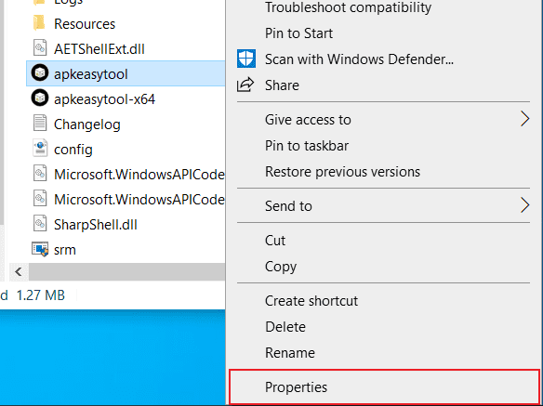

**Compatibilty**-> **Change high DPI settings**

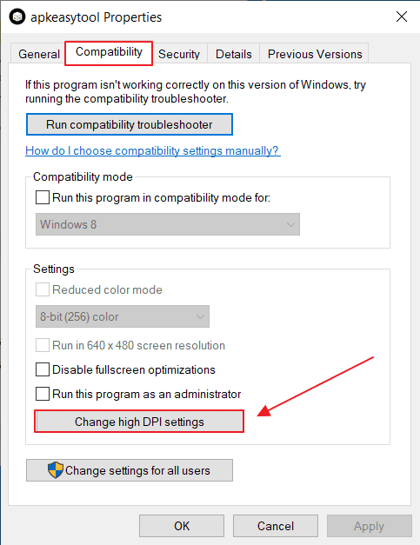

Check **Override high DPI scaling behavior** and select **Application** in the drop down

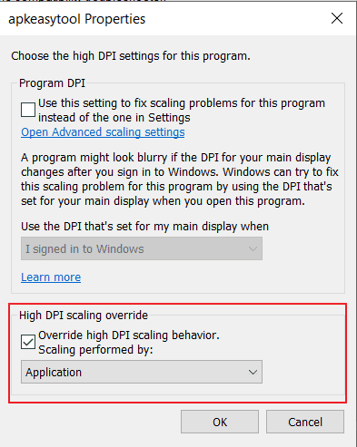

Click **OK** and **OK**  
  
**Q: Are spaces and symbols in filename supported?**  
A: Yes you can have spaces, symbols and special characters like germany, etc... in a filename unlike other tools.  
  
**Q: Why APK Easy Tool has been flagged as virus/malware?**  
A: First of all, all anti-virus softwares are NEVER 100% perfect like human and you should not always 100% trust the results. No anti-virus can be perfect  
There are many reasons why. Mostly it detecting the similar codes or behaviour that most criminals are using.  
I work very hard to avoid false positive as much as possible but it keeps detecting  
In general, most anti-viruses can flag any apps for money.  
  
I never make anything malcious and harm anyone in this community.  
  
**Q: Is drag and drop supported?**  
A: Yes it supports drag and drop APK/ZIP file  
Simply drop a file on buttons to do something.  
Examples:  
- Drop an APK file on "Decompile APK" button to  
decompile APK in the same directory  
- Drop an APK file outside (drop file on white background)  
to select APK to work on.  
  
**Q: How can I reset APK Easy Tool?**  
A: Go to Options -> General. Scroll down and click Reset to default.  
You can also manually delete or modify "config.xml" beside .exe  
  
**Q: Is APK Easy Tool collecting any data?**  
A: No, it doesn't. We respect your privacy very seriously  
It only have ability to connect to read-only secure server that checks for updates.  
  
**Q: Is APK Easy Tool free forever?**  
Yes, it's free forever. No ads, no premium, no PUP (Potentially unwanted program) and lifetime support  
  
**Q: Do you release the source code?**  
A: No, I don't because anyone can take advantage like changing credits and/or add malcious codes whatever in it easly  
Read these articles as example why open source is not always good idea:  
[https://www.bleepingcomputer.com/new...stall-malware/](https://www.bleepingcomputer.com/news/security/attackers-create-elaborate-crypto-trading-scheme-to-install-malware/)  
[https://blog.getpaint.net/2007/12/04...ware%E2%80%9D/](https://blog.getpaint.net/2007/12/04/freeware-authors-beware-of-%E2%80%9Cbackspaceware%E2%80%9D/)  
It's very easy to work with WinForm based on C#  
  
**Q: Alternatives?**  
A: Try out [Tickle​ My Android](https://forum.xda-developers.com/showthread.php?t=1633333), a command line tool that are also easy to use.  
But don't just think switching to other tool will solve any apktool issues, so don't forget to switch to apktool 2.3.4 or older to avoid strange issues